Transport Management System for
Intra-City travel
(Smart Vehicles)

PROJECT SYNOPSIS
OF MINOR PROJECT

BACHELOR OF ENGINEERING
IN
COMPUTER SCIENCE & ENGINEERING

SUBMITTED BY: SUBMITTED TO:
Deena Nath 0818CS161070 Ms. Astha Modgil
Birag Jain 0818CS161068



DEPARTMENT OF INFORMATION TECHNOLOGY

INDORE INSTITUTE OF SCIENCE & TECHNOLOGY
RAU PITHAMPUR ROAD, OPPOSITE IIM, RAU, INDORE 453331, M.P.
(Accredited by NBA, Affiliated to RGPV, Bhopal Approved by AICTE, New Delhi.)

JUNE -2019
Transport Management System for Intra-City travel
(Smart Vehicles)

Problem Statement
Public commute such as buses and metro don't have useful information. For example, if in-city buses had a system with information about the exact number of standing and sitting seats in the next metro or bus, then it would make using public transport very easy and amiable for citizens.
Introduction
In this project we provide the information of people available in buses and as well as number of vacant seats available to the passengers those are waiting for the bus in the next bus stop. And for displaying the information we can utilize the screen that are available on every bus stop. It will use both hardware and software. All details of hardware and software (see fig. 1) will be discussed later in the Technology stack part of the synopsis.
This project will be used in our day-to-day life. In this project we will involve both section of engineering called software and hardware. Programming language Python will be used. Module OpenCV Module of python will be used. And if we discussed about the Hardware part then it include RaspberryPi , PiCamera ,and GPS . In what way all these hardware and software will interact with each other we will discuss that in Proposed Solution.
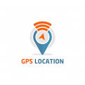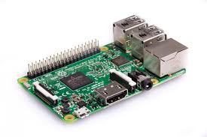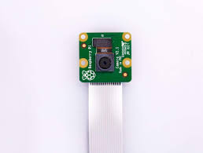
Python Library GPS Tracker Rapberry Pi Python PiCamera

Fig. 1
Proposed Solution
The Solution is comprised of several steps and here I explain step-by-step.
Step 1 => First we set up our PiCamera And GPS Module on Raspberry Pi. And make sure that your all connected devices are working properly.
Step 2 => Now we create a Database of Particular Route and we also store the coordinate system of every stop that we create in Database.
Step 2 => At every stop GPS module send the current stop and the image from the inside the bus to cloud.
Step 4 => Here we will process the image and get the number of human faces appeared in picture and according to that we will calculate the number of people in the bus.
Step 5 => If we find the less number of faces in picture than Total seats in the bus then we will calculate the number of vacant seats.
Step 5 => And if we find more number of faces in picture then we can make a statement about how many people are in bus.
Step 6 => Face Detection Technique is implemented using OpenCV which use Haarcascade Classifier.
Step 7 => Accuracy totally depends on Harrcascade Classifier. So, we examine the classifier in all worst condition.
Step 8 => After processing , we have the data of number of vacant seats (if available) and number of people in the bus.
Step 9 => Now, we again access the Database set which we created earlier and as per the record we send the message on the screen of the next bus stop.
Step 10 => We will not send only data to only next stop but also store it in another data set which we will use to predict next day as per the previous day.
So by applying all above steps we can achieve our goal to show the number of people in the bus and number of vacant seats in the bus to the passengers those waiting for the bus in the next stop.

Note – All the Terminology of devices name which are used above are shown in Technology Stack with their name and uses. Refer (Fig 2 & Fig 3).
Objective
Through this project, we will develop a system which will provide the information of people available in bus and as well as number of vacant seats available in the bus to the passengers those are waiting for the bus in the next bus stop.

Future Scope
We are going to develop an Application which will connect all the buses with the availability of seats with their current location of bus. According the seat availability in the buses people can plan their journey.
We will devise an algorithm which also tell the passengers about time required to reach their destination if they will leave any bus due to non-availability of seats, according to that passengers can choose the bus as per their convenience.
Here we can also implement the concept of machine learning. For better understanding let take an example we will store the data of every day of every bus and as per the previous data set we will also let the passenger know that in previous days what’s the situation.

Innovativeness and Usefulness
With this project we can develop a concept of smart vehicles which is equipped with sensor and now we have more information about the all the parameter of the bus.
It is useful in many ways :-
- Now people can avoid the buses in which more people are present.
- If Bus Authority wants then they can increase the frequency of buses as the frequency of passengers increase in particular route.
- If we introduce the application by which an user can check status from home then they can plan their journey.

Technology and Programming Language
Technology
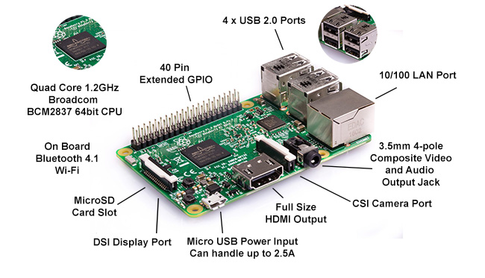 | 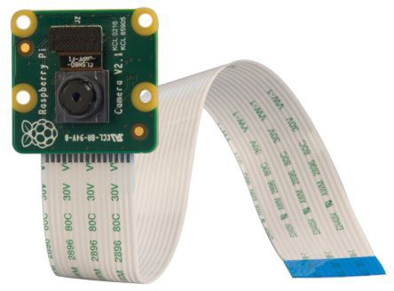 | 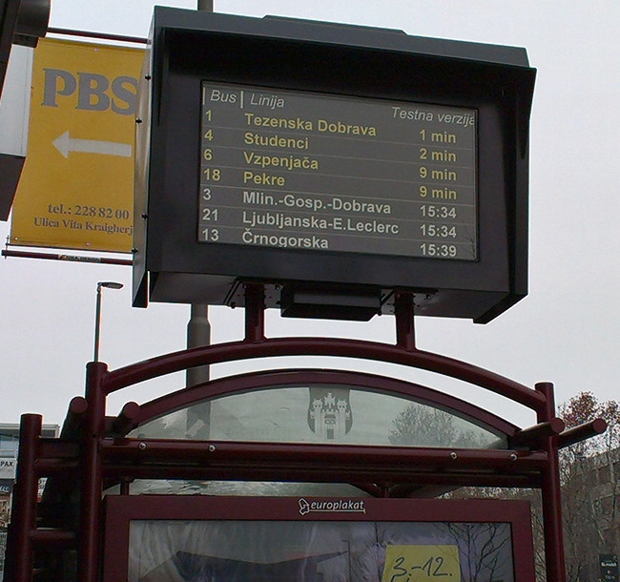 | 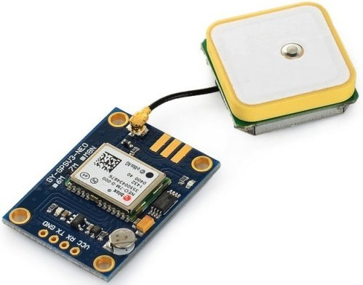
RaspberryPi (a) | PiCamera (b) | Monitor (c) | GPS Module (d)
The Raspberry Pi is a series of small single board computer developed in United Kingdom by the Raspberry foundation to promote teaching of basic computer science in schools and in developing countries.  The Raspberry Pi Foundation provides Raspbian a Debian-based Linux Distribution for download. | The Raspberry Pi camera module can be used to take high-definition video, as well as stills photographs. It’s easy to use for beginners, but has plenty to offer advanced users if you’re looking to expand your knowledge. There are lots of examples online of people using it for time-lapse, slow-motion and other video cleverness. | A computer monitor is an output device that displays information in pictorial form. A monitor usually comprises the display device, circuitry, casing, and power supply. The display device in modern monitors is typically a thin film transistor liquid crystal display (TFT-LCD) with LED backlight. | A GPS navigation device, GPS receiver, or simply GPS is a device that is capable of receiving information from GPS satellite and then to calculate the device's geographical position. Using suitable software, the device may display the position on a map, and it may offer directions.
It used for integrating the PiCamera and GPS module. | It is used to take a picture or record video from inside the bus. | We will use the monitor available on bus stop for showing our results. | It will track the location of the bus and according that we will process the information.
Fig. 2

Programming Language
 | 
Python (a) | OpenCV (b)
Python is an interpreted, high-level, general-purpose programming language. Python has a design philosophy that emphasizes code readability, notably using significant whitespace. | OpenCV is a library of programming functions mainly aimed at real-time computer vision. Originally developed by Intel, it was later supported by Willow Garage then Itseez. The library is cross-platform and free for use under the open-source BSD license.
This language named Python will be used for development of project . | This Library of Python specially used for face detection using Haarcascade Classifier .
Fig. 3
Conclusion
The main objective of this project to make the Transportation system for intra-city travel smart. All the process of implementation were already discussed. And we can understand from the future scope of the project that in upcoming days it’s going to play a vital role as we are progressing in our day to day life. We don’t know about the crowd in transport either it’s bus, train , metro and any public transport . So in upcoming days it’s become very useful for the people who uses the public transport frequently.

References :-
- http://sih.gov.in/sih2019ProblemStatements
- https://www.raspberrypi.org/
- https://www.python.org/
- https://opencv.org/

